Capstone Project Submission Report

1. Project Title
- Azure Cloud Data Engineering for BFSI: Scalable ETL and Real-Time Analytics Solution

2. Student Information
- Name: Prateek Baisla
- Student ID: 127232
- Course/Program: Data Engineering Training
- Instructor Name: Mr. Piyush

3. Problem Definition and Objectives

Problem Definition:

The fictional financial institution processes millions of transactions daily and needs to analyze this data for fraud detection, risk assessment, and regulatory compliance. The institution requires a scalable, secure, and cost-optimized solution for ingesting, transforming, and storing data from various sources, including banking APIs, structured databases, and event-driven streams.

Objectives:

Ingest Historical and Real-Time Data: Ingest data from both historical (CSV/Parquet) and real-time (JSON messages) sources.

Data Transformation: Clean, normalize, and transform the data for analysis.

Data Storage: Securely store the transformed data in Azure SQL Database and Azure Cosmos DB.

Real-Time Processing: Process real-time transaction data to trigger alerts for suspicious activities.
- Optimization: Ensure high availability, scalability, and cost optimization.

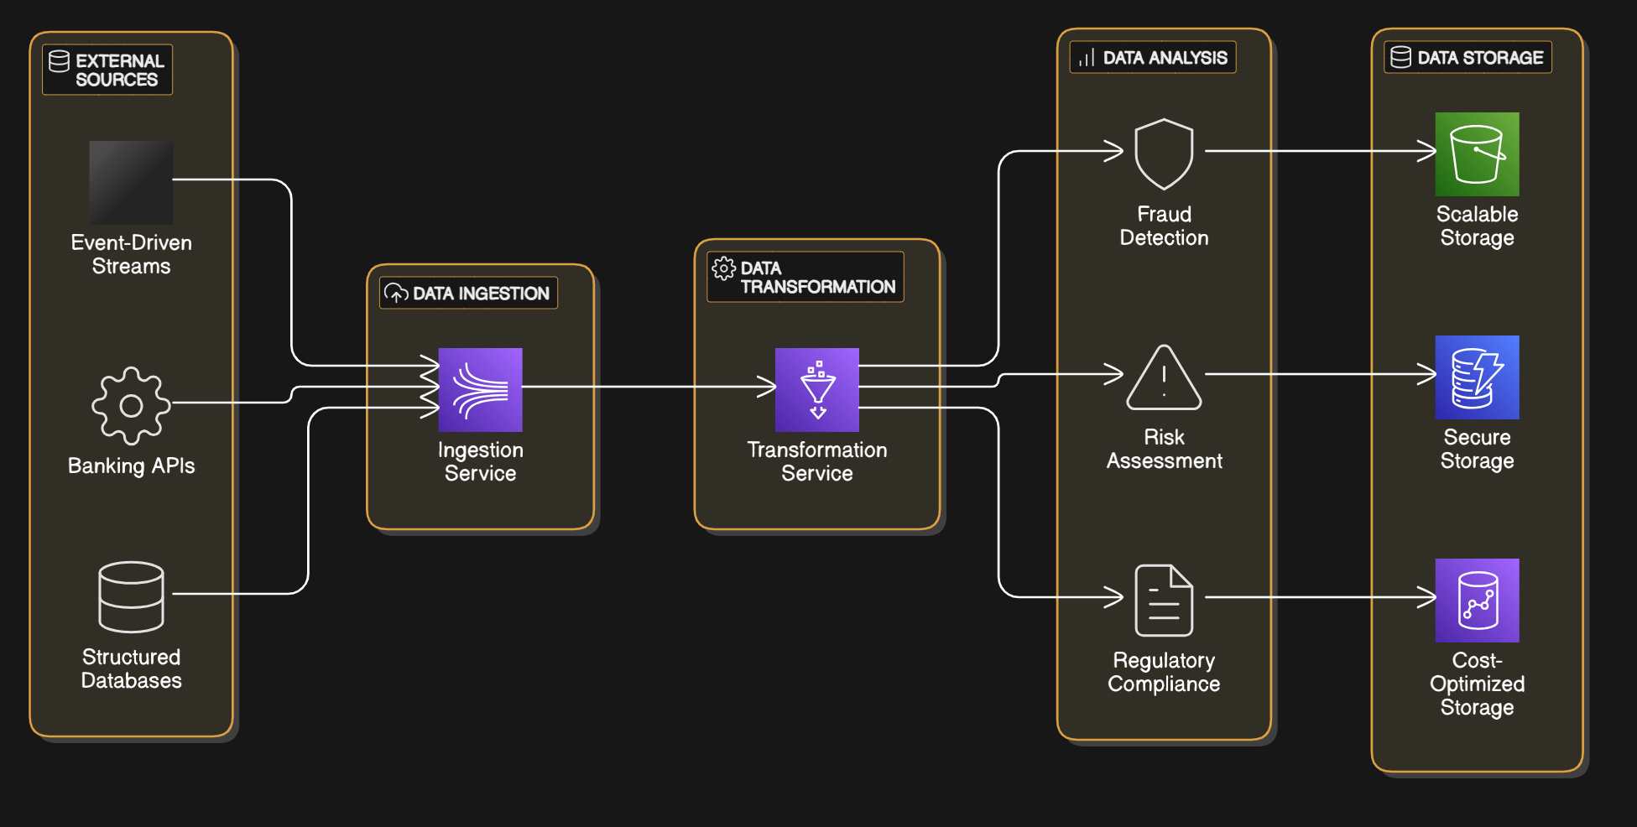

Medallion Architecture

Medallion architecture is a data design pattern used to logically organize data in a lakehouse, aiming to incrementally and progressively improve the structure and quality of data as it flows through each layer of the architecture

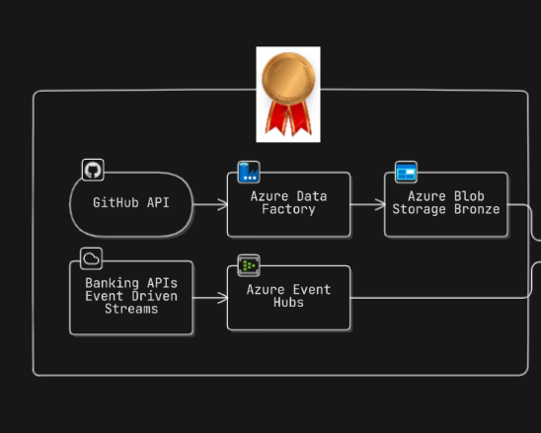

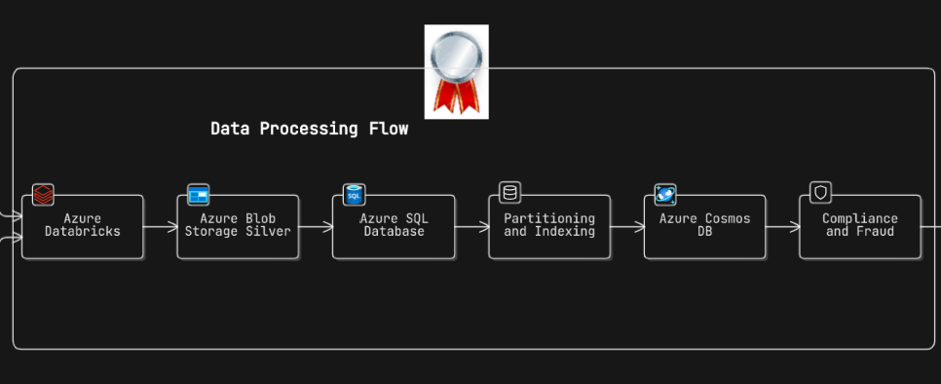

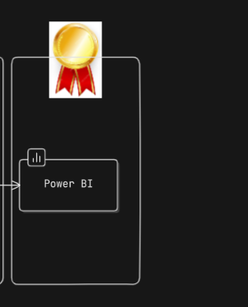

Diagram: High-Level Overview of Problem Context

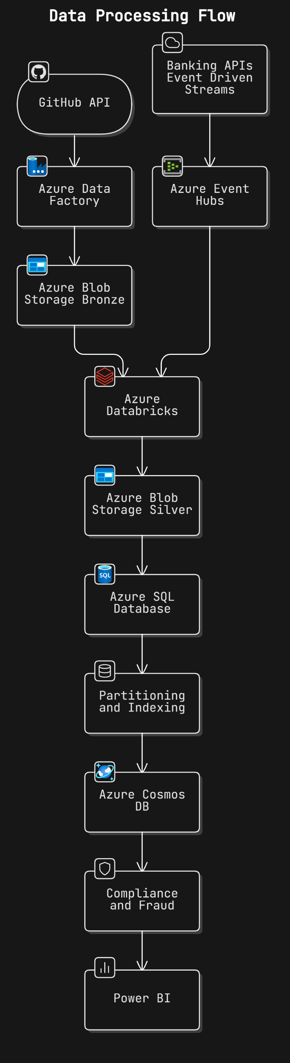

4. Data Collection, Exploratory Data Analysis (EDA), and Preprocessing

Data Collection:

Data is collected from various sources including Azure Blob Storage for historical data and Azure Event Hub for real-time data. Challenges included ensuring data completeness and consistency across different sources.
Historical -
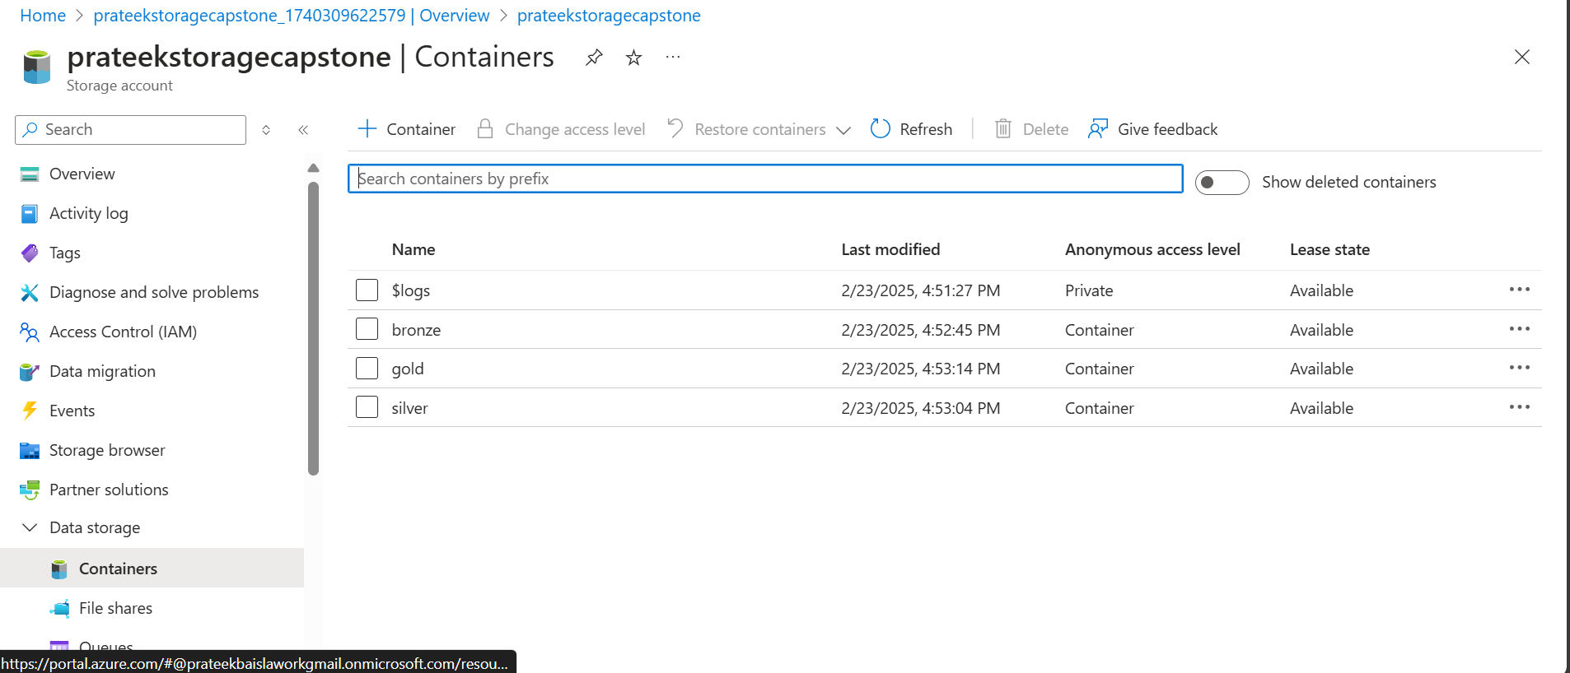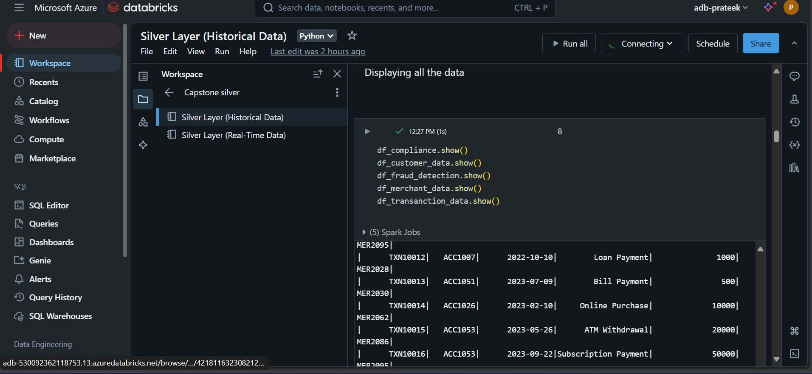
Real Time -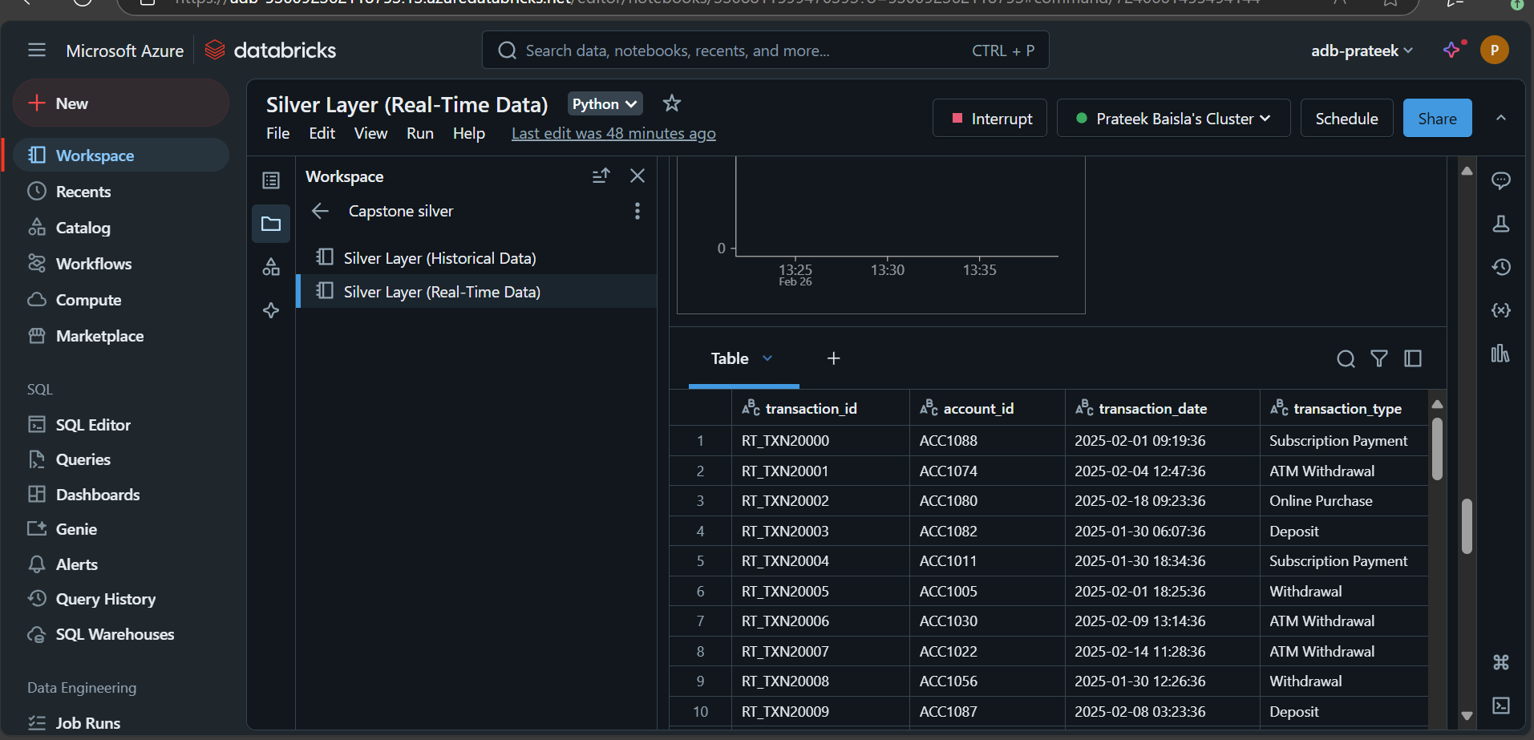

Table: Data Description
Attribute Name | Data Type | Description | Missing Values (%)
transaction_id | Integer | Unique ID for a transaction | 0%
account_id | Integer | Unique ID for an account | 0%
transaction_date | Date | Date of transaction | 0%
transaction_amount | Float | Amount of transaction | 0%
transaction_type | String | Type of transaction | 0%
merchant_id | Integer | Unique ID for a merchant | 0%

Exploratory Data Analysis:

Patterns and trends were discovered, such as peak transaction times and common transaction types.
Peak Transaction Times
- Monthly Peaks: Certain months like January, February, and December seem to have higher transaction volumes.
- Date Peaks: Dates like the 10th, 22nd, and 27th appear to have multiple transactions.
Common Transaction Types
- Bill Payments and Loan Payments are frequent, indicating regular monthly expenses.
- Withdrawals and Deposits are also common, which shows active account management.
- Subscription Payments appear periodically, suggesting recurring services.
High-Value Transactions
- Deposits: Highest value recorded is ₹200,000.
- Loan Payments: Amounts of ₹200,000 are seen, likely reflecting major debt payments.
Frequent Merchants
- MER2071, MER2095, MER2012: These merchants appear multiple times, indicating regular transactions with these entities.
Patterns in Amounts
- Round Numbers: Many transactions are in multiples of ₹500 or ₹1000.
- High-Value Withdrawals: Withdrawals of ₹50,000 and ₹70,000 are notable.

Data Preprocessing:

Steps included handling missing data with mean imputation, normalizing data using Min-Max normalization, and feature engineering.
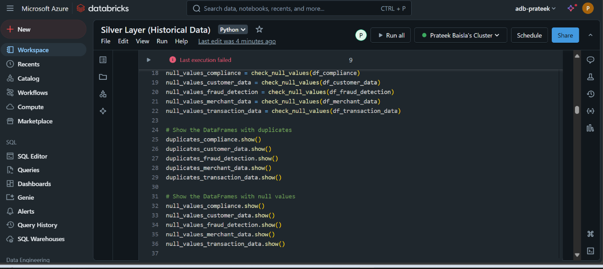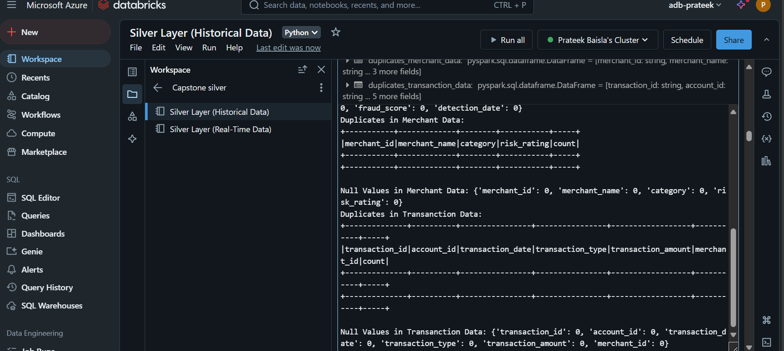

Table: Data Preprocessing Summary
Step | Technique | Result
Handle Missing Data | Mean Imputation | Missing values reduced
Feature Scaling | Min-Max Normalization | Scaled between 0-1

5. Data Storage and Optimization

Data Storage Solution:

Azure SQL Database and Azure Cosmos DB were chosen for their scalability, security, and performance.
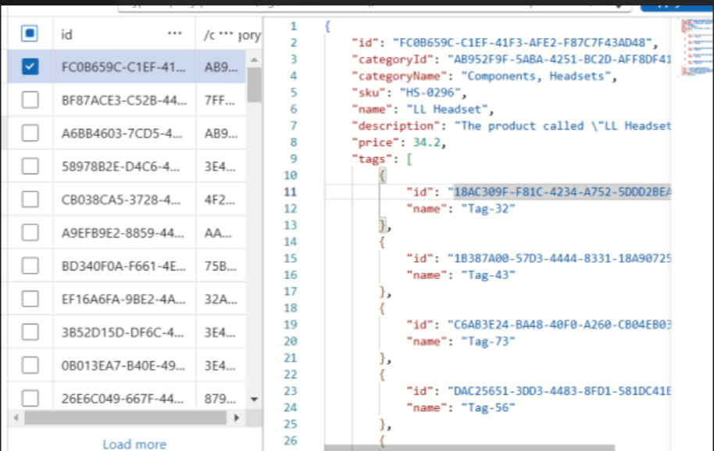

Diagram: 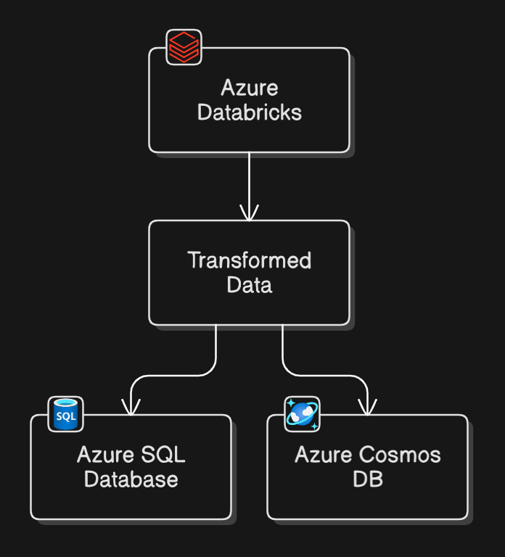

Partitioning & Indexing Strategies:
Optimization Technique | Purpose | Benefit
Partitioning | Split datasets | Improved query performance
Indexing | Key columns indexed | Faster data retrieval

6. Real-Time Data Processing and Streaming

Real-Time Data Processing:

Real-time data is processed using Azure Databricks connected to Azure Event Hub. This setup enables the processing of live transaction data and triggering of alerts for suspicious activities. 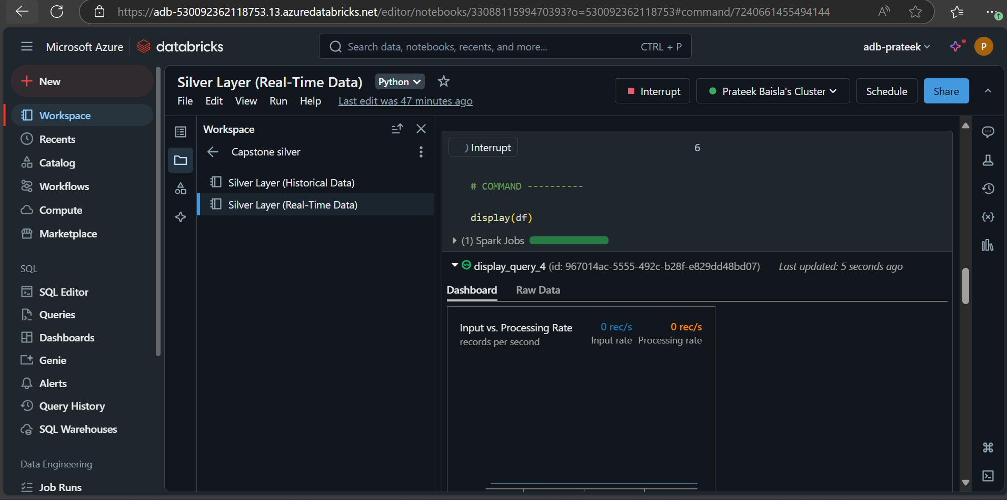

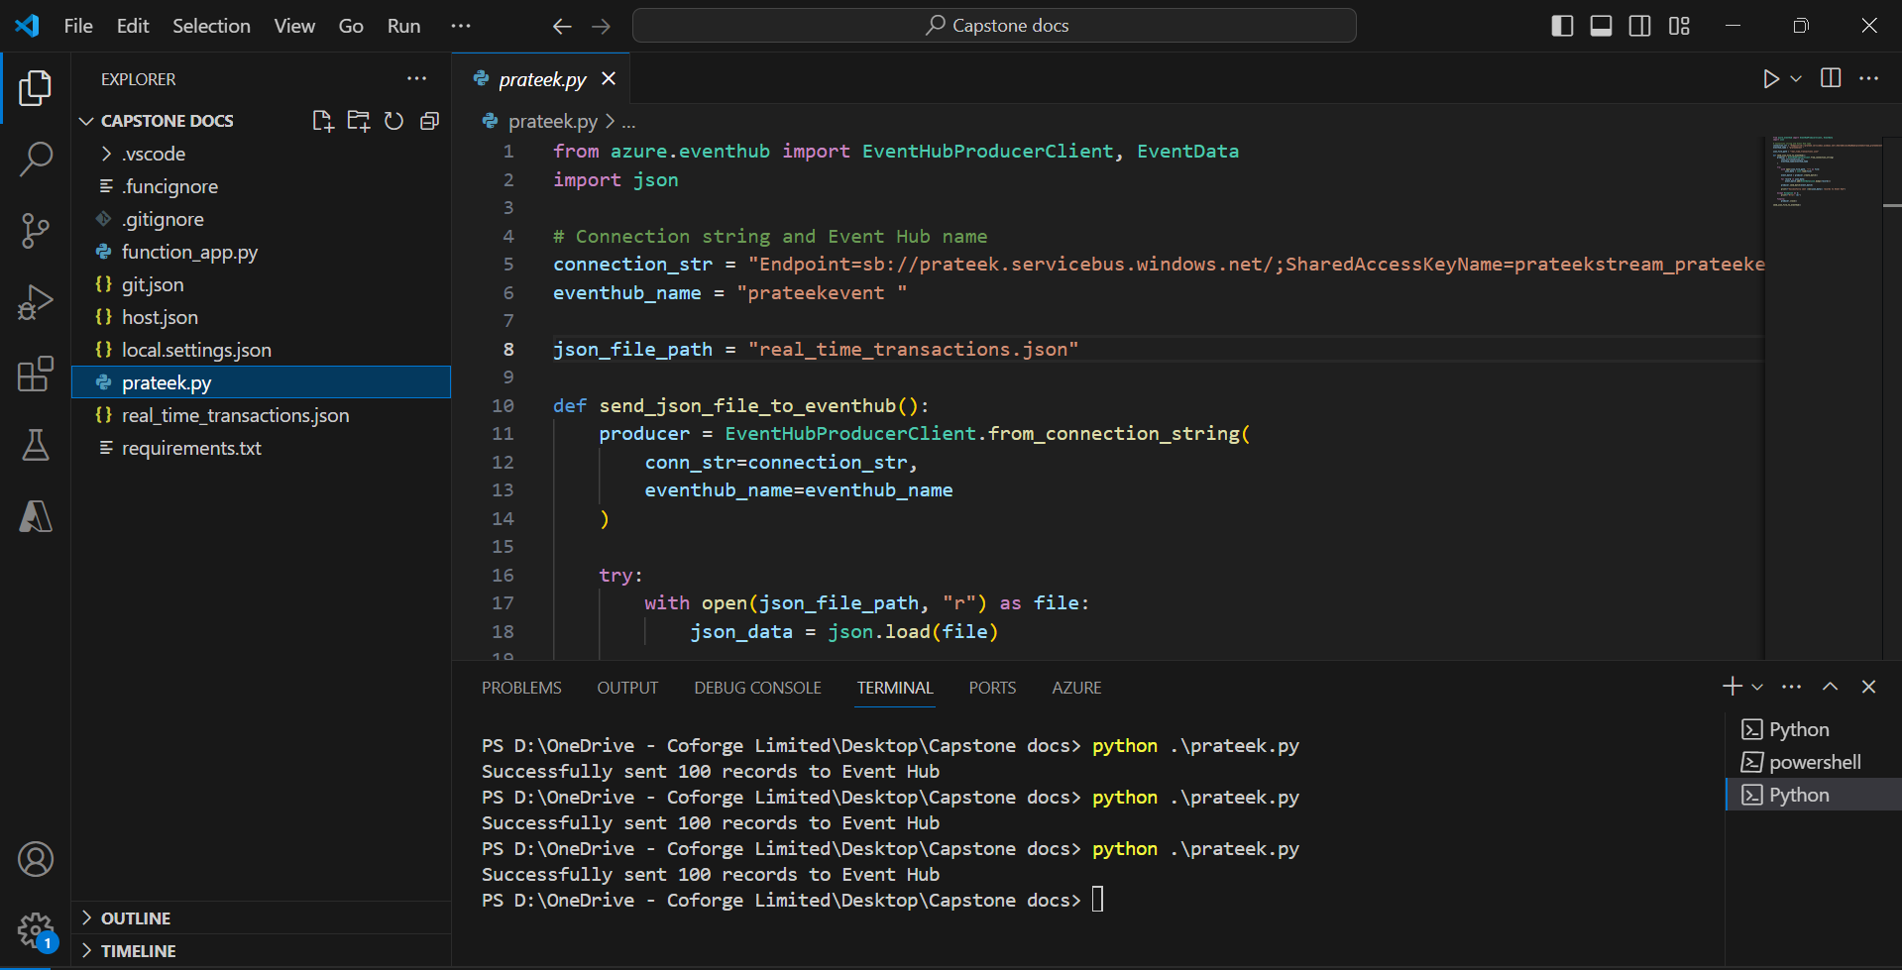
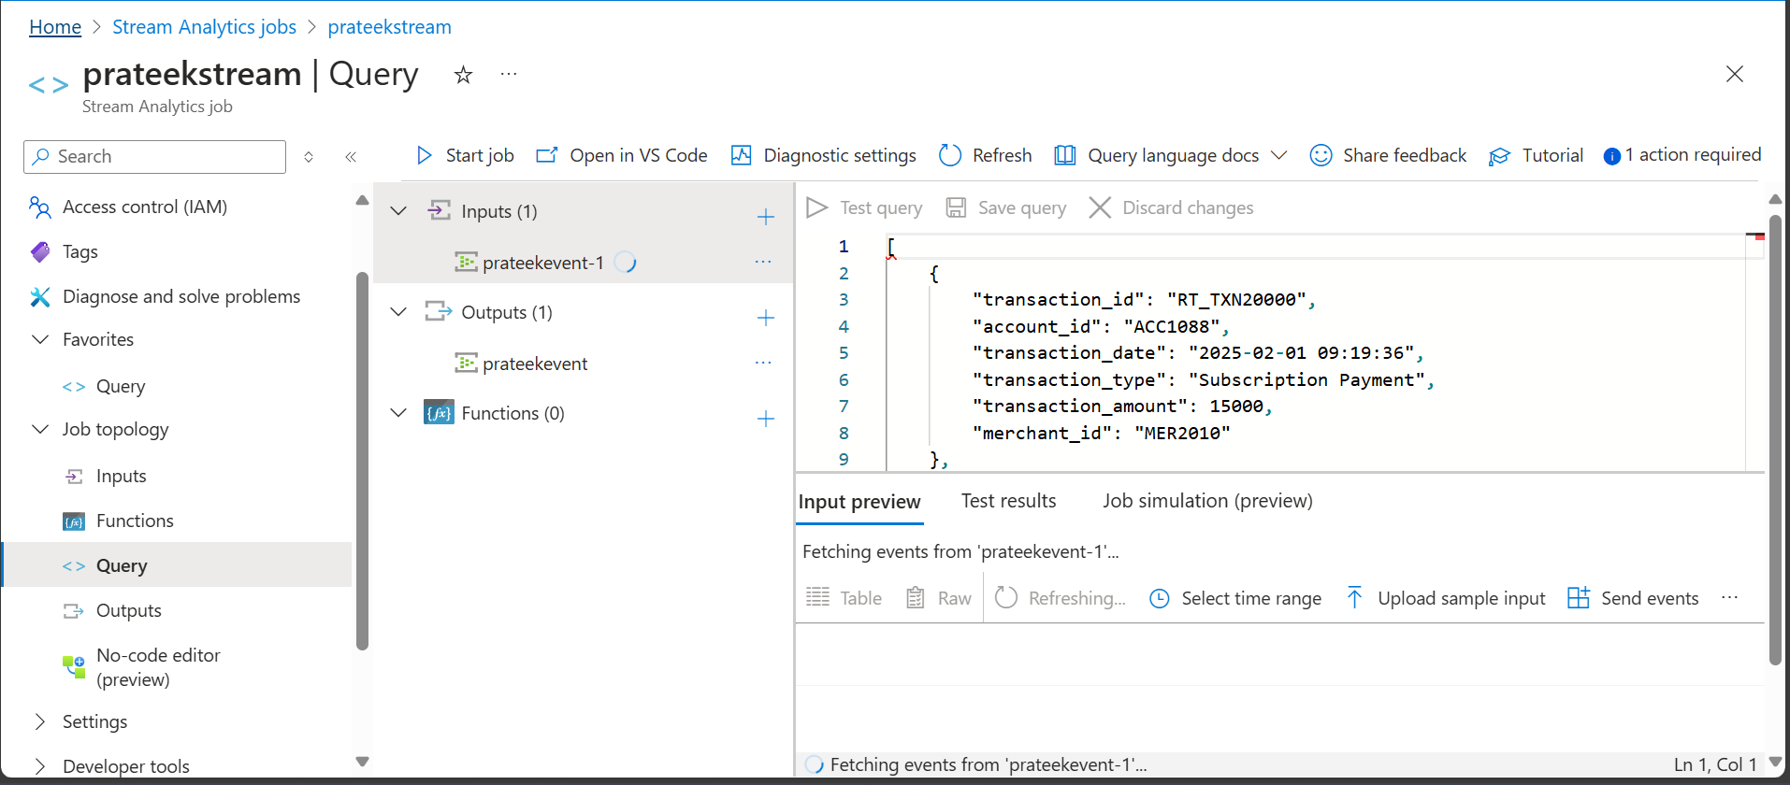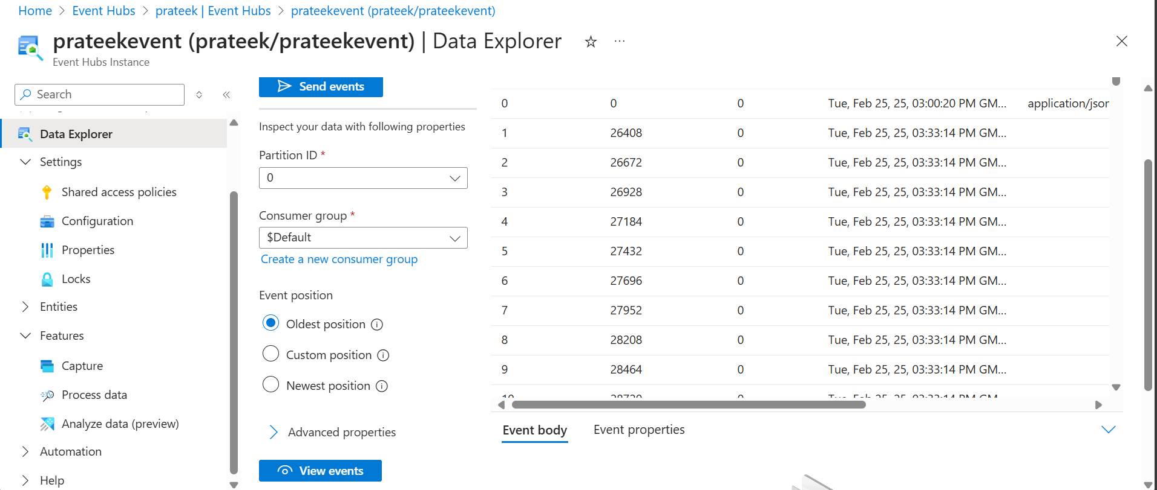
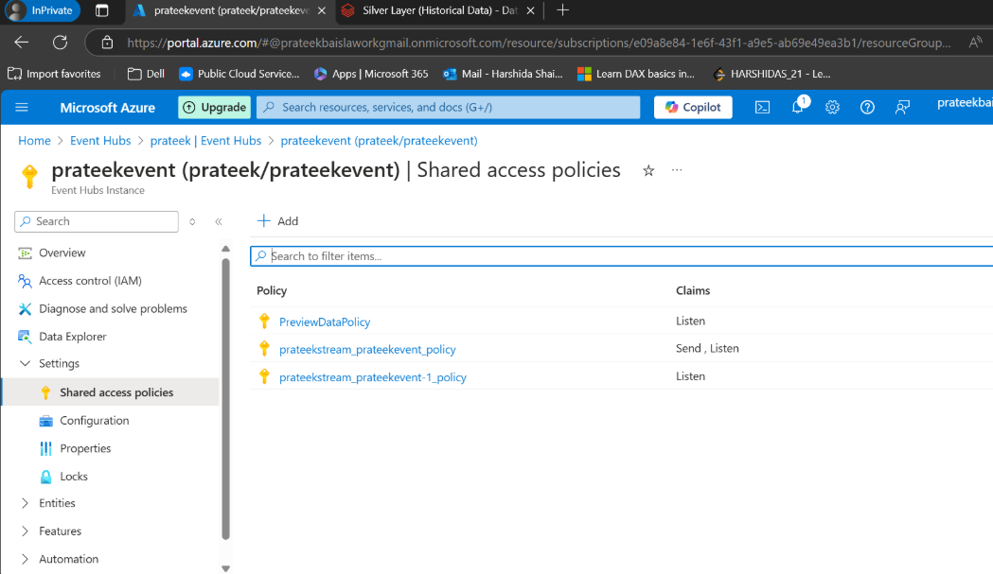
Diagram: Real-Time Data Flow
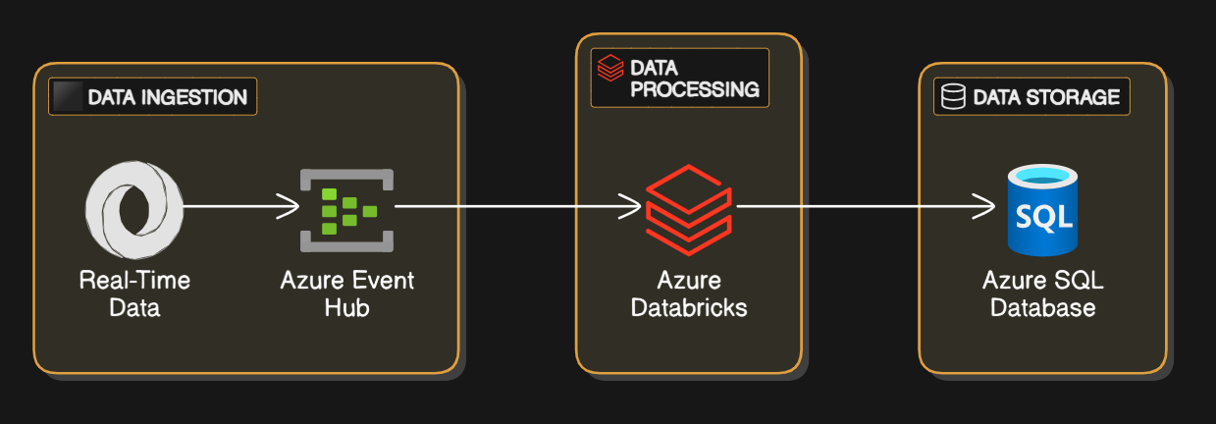

Triggering Events:
Event Type | Trigger Condition | Action/Outcome
Data Arrival | New data added | Start processing
Threshold Breach | Metric exceeds limit | Send alert

7. Solution Design & Integration

Complete ETL Process with Orchestration:

The ETL pipeline includes data extraction from Azure Blob Storage and Event Hub, transformation using Azure Databricks, and loading into Azure SQL Database and Azure Cosmos DB.

Diagram: System Architecture

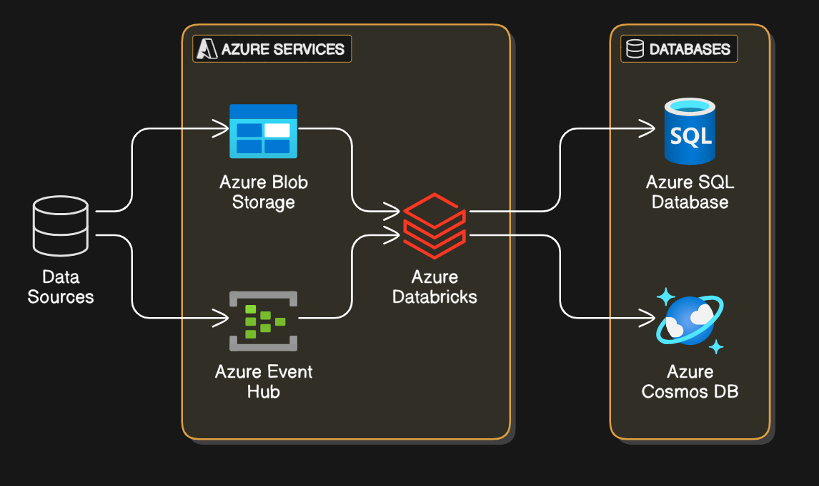Automated Workflows:

Automated workflows were set up using Azure Data Factory for scheduling and orchestrating the ETL processes.

Table: Component Breakdown
Component | Responsibility | Technology Used
Data Ingestion | Collect raw data | Azure Blob Storage, Event Hub
ETL Processing | Transform and load data | Azure Databricks
Data Storage | Store processed data | Azure SQL Database, Cosmos DB

8. Implementation and Results

Workflow/Process Flow:

The end-to-end workflow includes data ingestion, transformation, and storage, followed by real-time processing and alerting.

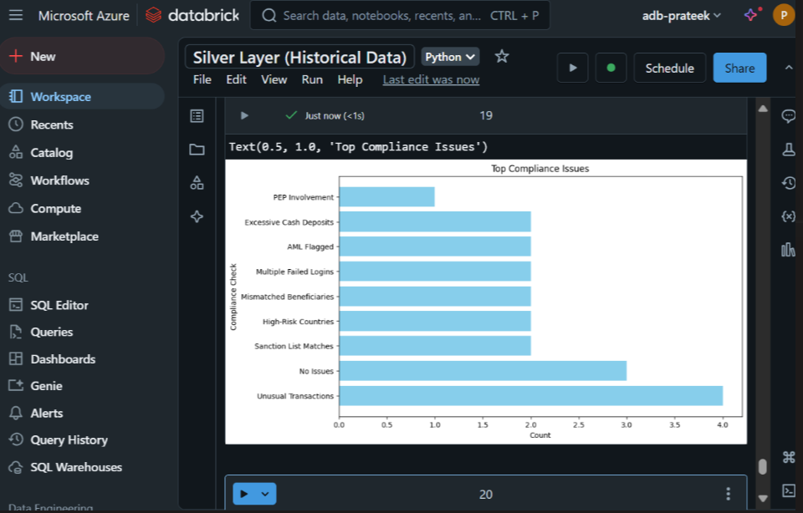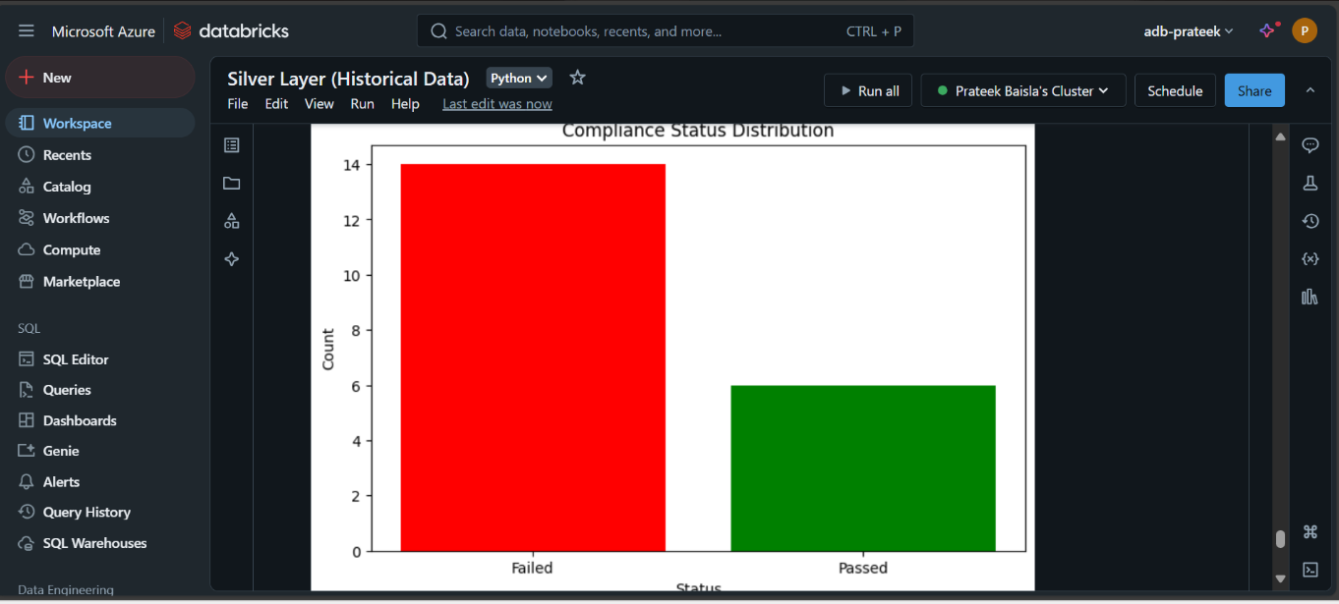

9. Conclusion and Future Work

Future Enhancements:

Proposals include integrating additional data sources and enhancing the fraud detection algorithm.

Diagram: Future System Enhancements

(Illustrate potential system expansions)

10. Final Presentation

Dashboard Screenshots:

(Include screenshots of final dashboards or data visualizations)

Table: Insights from Dashboard
Insight | Explanation/Impact
Anomaly Detection | Identified outliers in real-time
Predictive Alerts | Enabled proactive decision-making

11. Appendices

Appendix A: Code Snippets: Include important code or algorithms used in the project.

Appendix B: References: List references, citations, or sources used in the project.

12. Total Score Summary

Mid Report: /50

Final Report: /50

Overall Score: /100
